1. #include <stdio.h>
2. #include <stdbool.h>
3.
4. char board[3][3];
5.
6. void printPanduan() {
7. printf("Panduan posisi (1–9):\n");
8. for (int i = 0; i < 3; i++) {
9. for (int j = 0; j < 3; j++) {
10. printf(" %d ", i * 3 + j + 1);
11. if (j < 2) printf("|");
12. }
13. printf("\n");
14. if (i < 2) printf("---+---+---\n");
15. }
16. printf("\n");
17. }
18.
19. void printBoard() {
20. printf("\n");
21. for (int i = 0; i < 3; i++) {
22. for (int j = 0; j < 3; j++) {
23. printf(" %c ", board[i][j]);
24. if (j < 2) printf("|");
25. }
26. printf("\n");
27. if (i < 2) printf("---+---+---\n");
28. }
29. printf("\n");
30. }
31.
32. bool Winner(char player) {
33. for (int i = 0; i < 3; i++) {
34. if ((board[i][0] == player && board[i][1] == player && board[i][2] == player) ||
35. (board[0][i] == player && board[1][i] == player && board[2][i] == player)) {
36. return true;
37. }
38. }
39. if ((board[0][0] == player && board[1][1] == player && board[2][2] == player) ||
40. (board[0][2] == player && board[1][1] == player && board[2][0] == player)) {
41. return true;
42. }
43. return false;
44. }
45.
46. bool Draw() {
47. for (int i = 0; i < 3; i++) {
48. for (int j = 0; j < 3; j++) {
49. if (board[i][j] == ' ') return false;
50. }
51. }
52. return true;
53. }
54.
55. void getCoordinates(int move, int *row, int *col) {
56. *row = (move - 1) / 3;
57. *col = (move - 1) % 3;
58. }
59.
60. void playerMove(int playerNum, char symbol) {
61. int move, row, col;
62. while (1) {
63. printf("Pemain %d (%c), pilih petak (1–9): ", playerNum, symbol);
64. scanf("%d", &move);
65. if (move < 1 || move > 9) {
66. printf("Angka di luar jangkauan, coba lagi.\n");
67. continue;
68. }
69. getCoordinates(move, &row, &col);
70. if (board[row][col] != ' ') {
71. printf("Petak itu udah diisi, pilih yang lain.\n");
72. continue;
73. }
74. board[row][col] = symbol;
75. break;
76. }
77. }
78.
79. int evaluate() {
80. if (Winner('O')) return 10;
81. if (Winner('X')) return -10;
82. return 0;
83. }
84.
85. int minimax(int depth, bool isMaximizing) {
86. int score = evaluate();
87. if (score == 10 || score == -10) return score;
88. if (Draw()) return 0;
89.
90. if (isMaximizing) {
91. int best = -1000;
92. for (int i = 0; i < 3; i++) {
93. for (int j = 0; j < 3; j++) {
94. if (board[i][j] == ' ') {
95. board[i][j] = 'O';
96. int val = minimax(depth + 1, false);
97. if (val > best) best = val;
98. board[i][j] = ' ';
99. }
100. }
101. }
102. return best;
103. } else {
104. int best = 1000;
105. for (int i = 0; i < 3; i++) {
106. for (int j = 0; j < 3; j++) {
107. if (board[i][j] == ' ') {
108. board[i][j] = 'X';
109. int val = minimax(depth + 1, true);
110. if (val < best) best = val;
111. board[i][j] = ' ';
112. }
113. }
114. }
115. return best;
116. }
117. }
118.
119. void botMove() {
120. int bestVal = -1000;
121. int bestRow = -1, bestCol = -1;
122. for (int i = 0; i < 3; i++) {
123. for (int j = 0; j < 3; j++) {
124. if (board[i][j] == ' ') {
125. board[i][j] = 'O';
126. int moveVal = minimax(0, false);
127. board[i][j] = ' ';
128. if (moveVal > bestVal) {
129. bestRow = i;
130. bestCol = j;
131. bestVal = moveVal;
132. }
133. }
134. }
135. }
136. board[bestRow][bestCol] = 'O';
137. printf("Bot milih petak %d\n", bestRow * 3 + bestCol + 1);
138. }
139.
140. int main() {
141. int mode;
142. printf("=== TIC TAC TOE ===\n");
143. printf("1. Pemain vs Pemain\n");
144. printf("2. Pemain vs Bot\n");
145. printf("Pilih mode: ");
146. scanf("%d", &mode);
147.
148. printPanduan();
149.
150. for (int i = 0; i < 3; i++)
151. for (int j = 0; j < 3; j++)
152. board[i][j] = ' ';
153.
154. int currentPlayer = 1;
155. char currentSymbol = 'X';
156. bool gameOver = false;
157.
158. while (!gameOver) {
159. printBoard();
160. if (mode == 1 || currentPlayer == 1) {
161. playerMove(currentPlayer, currentSymbol);
162. } else {
163. botMove();
164. }
165.
166. if (Winner(currentSymbol)) {
167. printBoard();
168. if (mode == 1)
169. printf("Pemain %d menang!\n", currentPlayer);
170. else
171. printf(currentPlayer == 1 ? "Kamu menang!\n" : "Bot menang!\n");
172. gameOver = true;
173. } else if (Draw()) {
174. printBoard();
175. printf("Hasil seri!\n");
176. gameOver = true;
177. }
178.
179. currentPlayer = (currentPlayer == 1) ? 2 : 1;
180. currentSymbol = (currentSymbol == 'X') ? 'O' : 'X';
181. }
182.
183. printf("Game selesai!\n");
184. return 0;
185. }
186.

LAMPIRAN
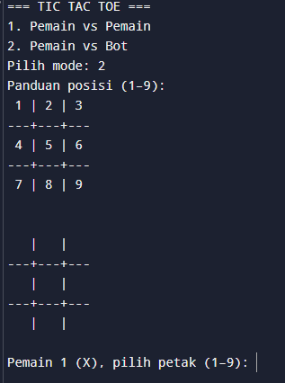
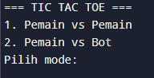
Awal Pilih Mode

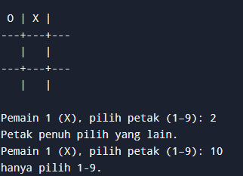
Salah

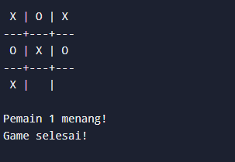
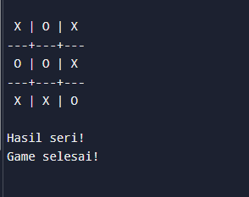
Selesai dan Seri
Selesai Menang

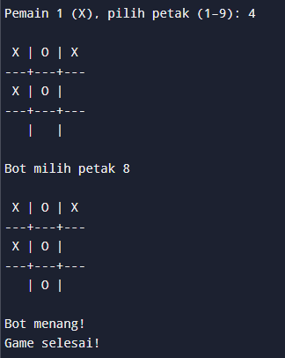
Selesai Kalah

